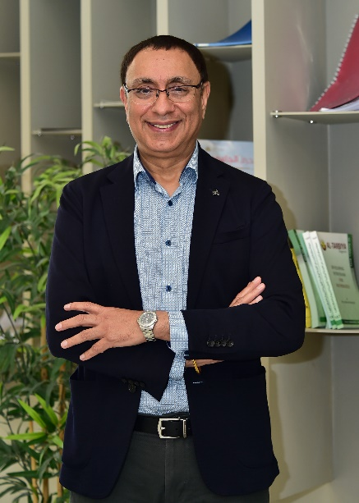**Prof. Mandeep Duggal**

Prof. Duggal is currently serving as the Dean of College of Dental Medicine, QU**.** Prof Duggal obtained his dental degree and MDS in Pediatric Dentistry from India. He then immigrated to the United Kingdom and obtained his FDSRCS from the Royal College of Surgeons of England and his PhD from the University of Leeds. He was appointed Professor and Chair of Child Dental Health at Leeds Dental Institute in 1999 where he oversaw a large postgraduate program in Pediatric Dentistry, which has international acclaim. In January 2017, he was appointed as Professor and Head of Pediatric Dentistry in the Faculty of Dentistry, National University of Singapore, and then as the Vice Dean and Faculty Research Director of the National University Centre for Oral Health, Singapore (NUCOHS). He has served in various senior positions, and was the President of the European Academy of Pediatric Dentistry from 2014-2016, and has been on the board of EAPD for the last 10 years. Professor Duggal has published over 170 research papers in international journals and is the author of “Restorative Techniques in Pediatric Dentistry, which has been published in 7 languages and has sold over 16,000 copies worldwide. He is also a co-author of a textbook on Dental Traumatology and has Co-Edited “Pediatric Dentistry” by Oxford, now in its 5th edition and is the most widely followed textbook in pediatric dentistry in the world. More recently he authored “Pediatric Dentistry at a Glance”, published by Blackwell Willey.

He has administered research grants totaling over seven million pounds and is an internationally recognized researcher and clinician with the main research interest in Cariology and Translation Research in Clinical Pediatric Dentistry, including dental traumatology and regenerative endodontics and auto-transplantatio

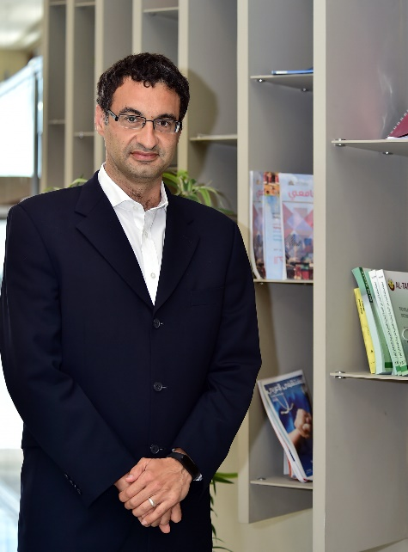**Prof. Faleh Tamimi**

Prof. Faleh Tamimi is currently serving as Associate Dean for Academic affairs of the College of Dental Medicine. Prof Tamimi holds a PhD degree in Biomaterials and specialty degrees in Geriatric dentistry and implant prosthodontics. His multidisciplinary and translational research covers various areas including the fields of biomaterials, tissue regeneration, inflammation, and chronobiology. He has published 1 book, and over 149 peer-reviewed articles that have received over 3000 citations, and he has an h-index of 31. He has received important awards including the W.W. Wood Excellence in Teaching Award from the Association of Canadian Faculties of Dentistry. His responsibilities in the college include overseeing the development and implementation of the dental undergraduate curriculum.

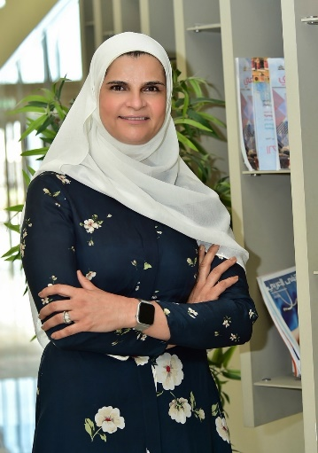**Prof. Elham Abu Alhaija**

Prof. Elham Abu Alhaija is currently serving as professor of orthodontics, College of Dental Medicine. She has completed a combined program PhD and clinical training in orthodontics from Queen’s University of Belfast after obtaining her undergraduate degree in dentistry from Jordan University of Science and Technology (JUST). She was awarded her PhD in 1997 and passed the MOrthRCS (Ed.) examination in 1998.

Currently, she teaches orthodontics at the college of dental medicine/ Qatar university. During her work at JUST, she was involved in teaching orthodontics for undergraduate and postgraduate students, conducting research and supervising postgraduate research projects. She has more than 65 publications (h-index 29; 2717 citations) and supervised more than 40 Master theses. Prof. Abu Alhaija was awarded 2 international prizes namely; Shoman award for Arab young researchers- Medical Sciences (2004) and Arab Dental Faculties Association award in the field of Orthodontics (2007).

Administratively, she served as Dean of Faculty of Dentistry/ JUST, Director of the Dental Teaching Center/DTC-JUST, Vice- dean of Scientific Research and later Acting Dean of Scientific Research/JUST, Vice- Dean of Faculty of Dentistry/JUST, Chairman of the Preventive Dentistry Department/JUST and Assistant Director DTC-JUST for Clinical Affairs.

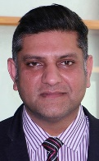**Prof Kamran Ali**

Kamran Ali is the Head of Preclinical Oral Sciences and a Professor of Oral Surgery. He is a Fellow of the Royal College of Surgeons England, Royal College of Surgeons in Ireland and the Royal College of Physicians and Surgeons Glasgow. He did his PhD from the Universities of Exeter, Plymouth (UK), and Master in Medical Education from the University of Dundee (Scotland). He was working as a Professor and Consultant in oral Surgery at the Plymouth University UK before moving to Qatar University.

Prof. Kamran has received international recognition in Dental Education and was awarded the Excellence in Dental Education, Mature Educator Award by the Association of Dental Education in Europe in 2017. He is recognized as a Principal Fellow of Higher Education Academy UK; Fellow, Faculty of Dental Trainers, Royal College of Surgeons Edinburgh; and National Teaching Fellow of Advance Higher Education, UK. He received the “Best Teacher” award by the Student Parliament, Faculty of Health at Plymouth University and the NHS Clinical Excellence Award in 2019.

Prof. Kamran is an Associate Editor of the European Journal of Dental Education and is on the Editorial Board of Evidence-based Dentistry published by Nature. He is a Board member reviewer for the British Journal of Oral and Maxillofacial Surgery. He has published over 100 papers on educational and clinical research in oral surgery and has edited a book entitled “Essential Physiology for Dental Students” published by Wiley and Sons; he has also authored over 50 chapters in multiple books on Dentistry. Prof. Kamran provided education consultancy to a wide range of organizations including the General Dental Council UK, Health Education England, Ministry of Education, Malta and numerous dental universities across the world.

Research Interests: Medical Education; Oral Surgery; Oral Cancer; Oral Mucosal Disease

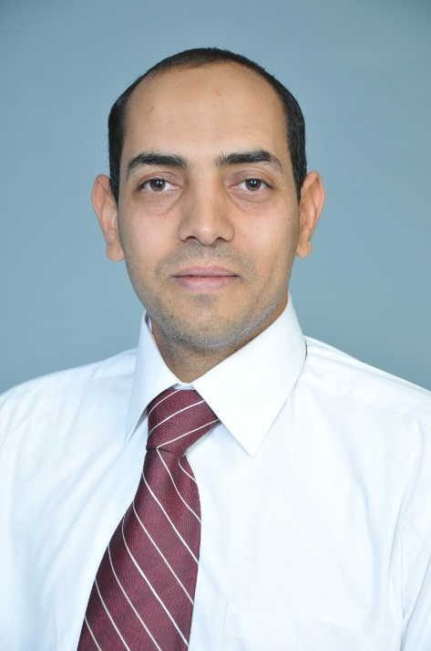

**Dr Sadeq A. Al-Maweri**

Dr Sadeq Al-Maweri is an Associate Professor of Oral Medicine and the Director of research and graduate studies, at the College of Dental Medicine, Qatar University. Dr Al-Maweri completed his Master degree (Oral Medicine) at the University of Science Malaysia in 2009, and his doctorate degree at Witten/Herdecke University, Germany in 2013. Dr Al-Maweri has been teaching Oral Medicine and diagnostic Sciences for over 8 years in Saudi Arabia and Qatar. In addition to teaching, Dr Al-Maweri has been actively engaged in research activities, and to date, he has published over 85 articles in highly reputed dental and medical journals.

Dr Al-Mewari’s’ research interests include tobacco-induced oral diseases; epidemiology and risk factors of oropharyngeal cancer; oral microbiome releted to oral cancer; oral health and systemic diseases; and evidence-based medicine.

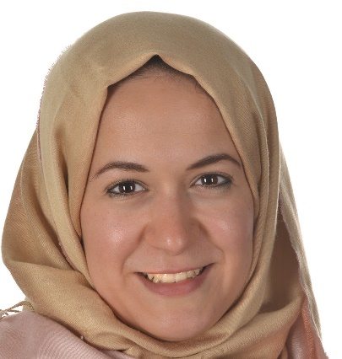

**Dr Manal Matoug-Elwerfelli**

**Assistant Professor**

Dr Manal Matoug-Elwerfelli is an Assistant Professor of Pre-Clinical Oral Sciences at the College of Dental Medicine, Qatar University. Dr Manal, has successfully completed her Clinical Masters in Restorative Dentistry with Distinction followed by her PhD in Regenerative Endodontics in 2018, both from the University of Leeds, UK. Dr Manal, holds a UK Dental License and a Membership Diploma in Royal College of Surgeons England (MJDF). She has presented her PhD thesis titled “Decellularisation of the Dental Pulp for Use as a Scaffold in Regenerative Endodontics” in several national and international conferences and won several awards including Young researcher of the year award at the European Academy of Paediatric Dentistry, 2016. Dr Matoug-Elwerfelli has also published several peer-reviewed papers in high-impact journals.

Dr Manal’s research interests lies in the field of dental trauma, regenerative endodontics, decellularised pulp scaffolds, alternative antimicrobials materials and strategies with a special focus towards a clinical translation approach.

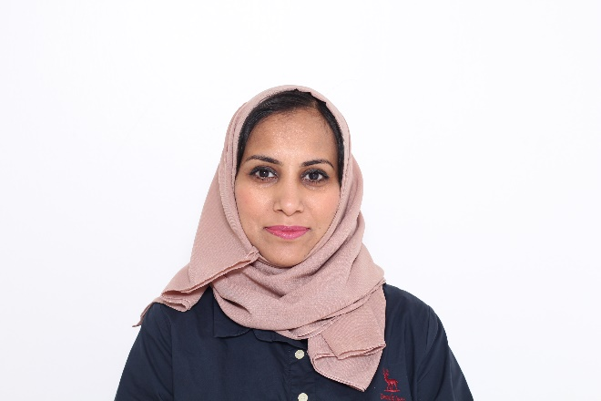

**Dr Raidan Bahattab**

Dr Raidan Ba-Hattab is an Assistant Professor of Endodontics at the College of Dental Medicine, Qatar University. She completed her specialty training in Endodontics and awarded her doctorate degree from Rostock University, Germany. Ba- Hattab has teaching experience in Germany and Saudi Arabia. She awarded a grant for a project “Artificial intelligence for early diagnosis of oral cancers: A Bayesian deep neural network” from Qatar University, 2021. Ba- Hattab has several publication in peer-reviewed journals. Her research interests include Artificial Intelligent in Dentistry, innovative technologies in Endodontics, Dental traumatology and dental biomaterials.

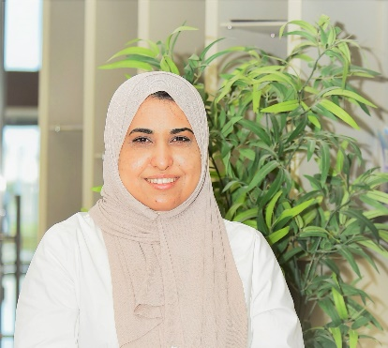**Dr. Lamyia Anweigi**

Dr Lamyia Anweigi is an Assistant Professor of prosthodontics in the College of Dental Medicine at the University of Qatar. Dr Anweigi is a dental graduate of College of Dentistry, University of Benghazi Libya. After undergoing rotation in clinical disciplines as part of the internship program, and work as demonstrator at the Dental school and Hospital Benghazi. Dr Anweigi moved to Cork, Ireland to complete her postgraduate study and her clinical training. She holds a PhD in "Clinical performance and subjective assessment of adhesive bridges in patients with Hypodontia" and Master of Medical Sciences in Restorative Dentistry (MMedS), (taught course) from the Dental School Hospital, University College Cork, Ireland. She got a Membership of the Faculty of Dental Surgery Royal College of Surgeon Ireland (MFDSRCSI). She worked as Clinical Research Assistant for ART (Atraumatic restorative Dentistry) at University College Cork, Dental School and Hospital, Ireland. Dr Anweigi moved to Princess Nourah Bint Abdulrahman University, Dental School and Hospital, Riyadh, Saudi Arabia and filled a position of Assistant Professor in Prosthodontics. Dr Lamyia’ s role in PNU was ranged from designing courses, teaching undergraduate students, conducting research, to other multiple administration duties. In August 2019, Dr Anweigi gained more experienced by joining the College of Dental Medicine, Qatar University to contribute to build up first Dental School in Qatar.

Her areas of interest include dental public health, oral health and quality of life (Qualitative and Quantitative studies), minimally invasive dentistry, clinical performance of dental treatment.

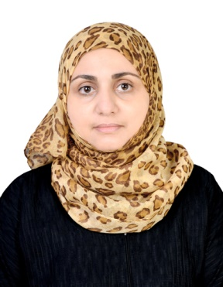**Dr. Abeer Al-mashraqi**

Dr. Abeer Al-mashraqi is an Associate Professor of Oral and Maxillofacial Radiology at the College of Dental Medicine, Qatar University. Dr. Al-mashraqi completed her Master's degree (Oral and Maxillofacial Radiology) in 2010, and her Ph.D. degree at Cairo University in 2014, Egypt. Both her Master and Ph.D. were focused on the advanced imaging modalities; Magnetic Resonance Imaging (MRI) of the temporomandibular joints and the dose reduction protocols of Computed Tomography (CT) and Cone Beam Computed Tomography (CBCT) of the maxillofacial region. Recently, she completed her postgraduate certificate in medical education from Warwick University, United Kingdom. She is an associate member of both the American Academy of Oral and Maxillofacial Radiology and the European Academy of DentoMaxilloFacial Radiology. Dr. Al-mashraqi has been teaching basic radiology, oral and maxillofacial radiology, dental implants, temporomandibular disorders, and Comprehensive Care Clinics to dental students and supervising the clinical diagnostic radiology unit for over 7 years in Saudi Arabia. In addition to teaching and clinical practice, Dr. Al-mashraqi has been actively engaged in research activities, and to date, she published many articles focused on dose management protocols and clinically oriented research, especially in the MRI and CT imaging of temporomandibular joints and maxillofacial complex. She was awarded the Clifton Simmons III, DDS Award for Excellence in Articles in 2021. Administratively, she was the head of the BDS implementation unit in the female section at the College of Dentistry in Saudi Arabia and the deputy head of the quality assurance and academic accreditation unit for more than four years and organized and guided the BDS program's full accreditation journey. She was a member of the external exam review committee and the technical subcommittee for scientific plans and curricula at the University level in Saudi Arabia and a member of the college advisory committee for 2 successive cycles.

|  |
| --- |
| **Dr. Nader Hamdan** |
| C:\Users\nh20253\OneDrive - Qatar University\Desktop\Nader\Dr. Nader Hamdan - Photo2.jpgDr. Nader Hamdan, BDS, MSc, Dent(Perio), FRCD(C), Diplomate ABP, FDS RCPS(Glasg) is an Associate Professor and current Head of Periodontics at the College of Dental Medicine, Qatar University, Qatar. He served also an Associate Professor and the former Director of the Graduate Periodontics Program, Faculty of Dentistry at Dalhousie University (Canada) for six years. He also served as the Chairman of Continuous Professional Education at the Faculty of Dentistry - Dalhousie University for many years before moving to Qatar. Dr. Hamdan obtained his BDS (DDS) degree in 1999 from Jordan University of Science and Technology, practiced general dentistry for 12 years before pursuing an MSc in dental sciences program at McGill University (Canada), which he completed in 2013. Dr. Hamdan's research at McGill focused on the differences in the dietary intake between mandibular complete denture wearers vs those wearing two-implant overdentures. The findings of this research were published in the reputable Journal of Dental Research ​special supplement on dental implantology. Dr. Hamdan went on to complete a three-year fully accredited MDent Periodontics program at the University of Manitoba (Canada). His research looked at the upregulation of one of the novel potential biomarkers within the gingival crevicular fluid of patients suffering from moderate-severe periodontal disease. In 2016, Dr. Hamdan obtained his second master’s degree - a Master in Dentistry (Specialty: Periodontics), passed both components of the Canadian National Dental Specialty Examination and was certified as a periodontist and later became Fellow of the Royal College of Dentists of Canada (FRCDC). Dr. Hamdan passed the examinations of the American Board of Periodontology and Dental Implant Surgery and became a Diplomate of ABP in 2017. Dr. Hamdan is also a Fellow of The Faculty of Dental Surgery, The Royal College of Physicians and Surgeons - Glasgow, UK. Having developed extensive experience in the field of periodontics, Dr. Hamdan has numerous publication in well-known peer reviewed journals, has co-authored 2 books, several book chapters, and conference publications on dental implantology and periodontics. He is also a reviewer for several international dental journals. Dr. Hamdan has supervised many graduate students’ research at the level of MSc and PhD both as main supervisor and supervisory committee member. Dr. Hamdan is an international speaker in periodontics, and has been invited to give lectures and continuous education courses in multiple countries around the world. As an international testament to his contribution to dental education, the American Academy of Periodontology recognized Dr. Hamdan in 2020 with the academy’s “2020 Educator Award in recognition of distinguished teaching and mentoring in periodontics” |

**Prof. Hani Nazzal**

Prof Hani Nazzal is a senior Consultant, Pediatric Dentistry, Hamad Medical Corporation and serves as an adjunct clinical professor of pediatric dentistry, College of Dental Medicine, Qatar University. Dr. Hani completed three years clinical training in Paediatric Dentistry at the University of Leeds in 2008 after which he obtained a Fellowship in Paediatric Dentistry from the Royal College of Dentists in Canada in the same year. He then worked as a Senior Dental Officer in Paediatric Dentistry at Bradford and Airedale Salaried Dental Services between 2008 and 2012. He became a member and then a fellow of the Royal College of Physicians and Surgeons of Glasgow (Paediatric Dentistry) in 2015 and 2016, respectively. He worked as an academic Paediatric Dentist consultant at University of Leeds in 2017. In 2018, Dr Hani was appointed as a senior consultant in Paediatric Dentistry at Hamad Medical Corporation. Academically, he obtained a PhD in paediatric Dentistry from the University of Leeds, School  of Dentistry in 2008. In 2012, he was appointed as a NIHR Clinical Lecturer in the paediatric dentistry Department where he was involved in undergraduate and postgraduate  education. Dr Hani has been appointed as clinical professor in paediatric dentistry, School of Dental Medicine, Qatar University. His research interests are in the field of dental Traumatology, regenerative endodontics, the use of laser Doppler flowmetry, fluoride anticariogenic effect, and education in dentistry. Prof Hani has multiple publications and co-authored several book chapters in addition to  presenting in several UK national and international conferences. In addition, Prof Hani is currently an associate editor of the Paediatric Dentistry and Orthodontic sections of Dental Traumatology journal and the endodontic section of the European Archives of Paediatric Dentistry.

**Dr Dilek Yigit :**

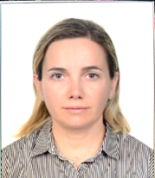**Dr. Dilek Yigit**

Dr. Dilek (Helvacioglu) Yigit is an Associate Professor of Endodontics at the College of Dental Medicine, Qatar University. Prior to joining Qatar University, Dr. Yigit served as the Chair of the Dept. of Endodontics, and also executive board member at Kocaeli University, Faculty of Dentistry in Turkey for 10 years. She graduated with a BDS in 2001 and a Ph.D. Degree in the field of Conservative Dentistry and Endodontics in 2009, both from Marmara University, Istanbul, Turkey. She became an Assistant Professor in 2011 and an Associate Professor in 2016. She has over 10 years of clinical experience as a specialist in endodontic practice. Since 2011, she has been involved in both undergraduate and postgraduate teaching in Endodontics. She has authored or co-authored 3 chapters in national books and more than 30 scientific papers in peer-reviewed journals in Dentistry. She has worked on several research projects and supervised graduate theses. She was awarded many grants from several institutions including “The Scientific and Technological Research Council of Turkey”. Her basic research interests focus on endodontic materials and the use of different imaging modalities in Endodontics including CBCT and Micro-CT. Dr. Yigit is a member of various professional organizations including the European Society of Endodontology and The International Association for Dental Research.