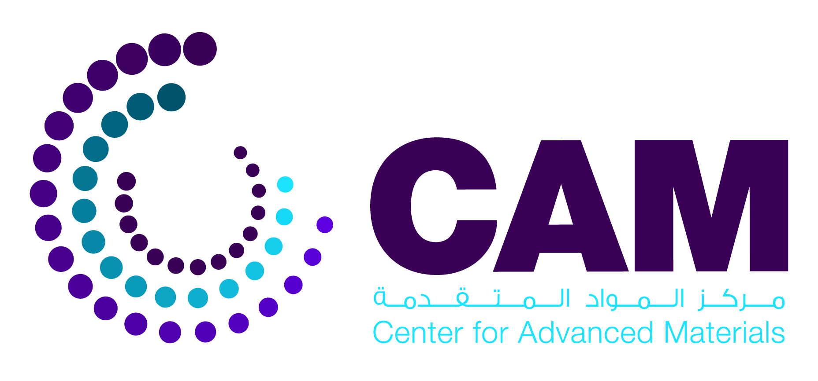 | 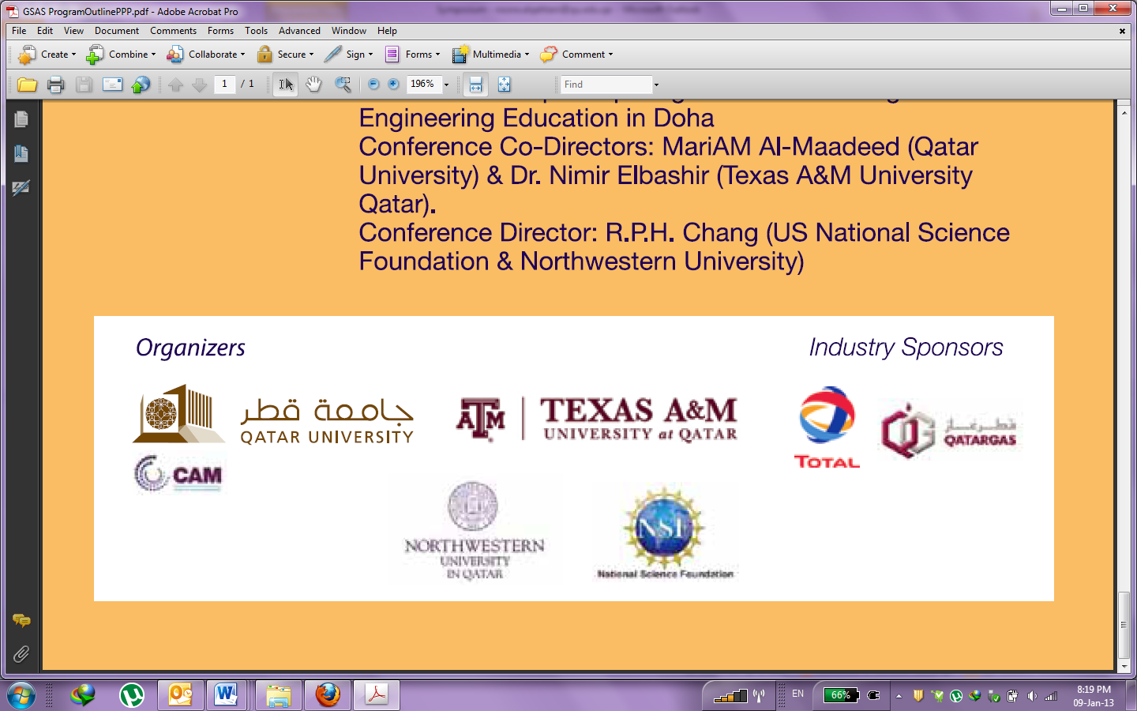

Mechanism of CAM Collaboration with Internal & External Researchers

Scope:
CAM has the vision of enhancing collaboration with internal and external researchers to:
1. Broaden the area of knowledge and expertise inside the centre.
2. Provide avenue and research facilities to young scientists.
3. Increase the visibility of CAM and QU.

Criteria, regulations, and expectations of potential collaborates at CAM
Priority for using the CAM facility will be for those:
1. Having major funding.
2. Having graduate/undergraduate QU students registered on the project.
3. Having equipment of applicable use in CAM.
4. Insuring CAM affiliation on any papers published from his/her work at CAM.
5. Align with CAM research activity.

Terms, conditions, and mechanism:
➢ Each collaborator who would like to occupy space at the CAM should provide a written request that will be studied by the management committee of the CAM (Online request form).
➢ Fill CAM required application forms.
➢ CAM need to be properly acknowledged to research and public outcomes and outputs.
➢ Extension of the project is applicable upon mutual agreement of both parties and outcome of the project.

Center for Advanced Materials
New Research Complex (NRC), Zone 6
Qatar University
P.O. Box: 2713, Doha, Qatar.
Web site: http://www.qu.edu.qa/offices/research/CAM/

*CAM Forms required to be completed as following:
1. Internal researchers using CAM facility 5 working days/ week: Form 3 & 4.
2. External researchers, need to work with CAM PI: Forms 1, 4 & QU confidentiality agreement), CAM PI complete form 3 for the same project.
3. Internal but temporary use of facility: Form 2 and/or form 4 for Master degree students.

